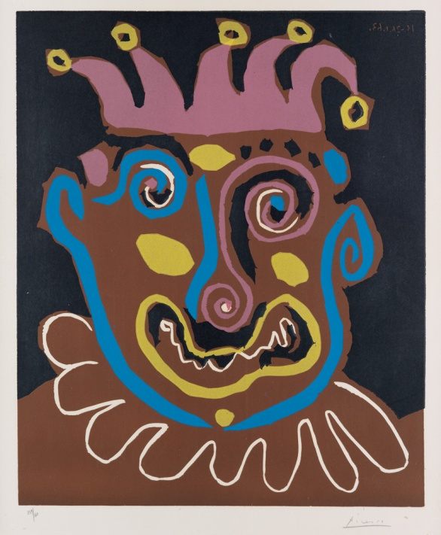

PABLO PICASSO
Le Vieux Roi.
Color linoleum cut, 1963. 640x526 mm; 25 1/4x20 3/4 inches, full margins. Signed and numbered 159/160 in pencil, lower margin. Printed by Arnéra, Vallauris. Published by Le Patriote, Nice. A superb, richly-inked impression of this large linoleum cut with vibrant colors. Bloch 1152; Baer 1338.

Prime Auctioneers, Inc.

14620 Keswick Street, Van Nuys, CA 91405 Tel: 818-778 6501 Fax:818-778 6508 Email: primeauction88@gmail.com

